A4011-MEX-Maya-Ballgame Yoke-Tlaloc-Andesite-900 CE

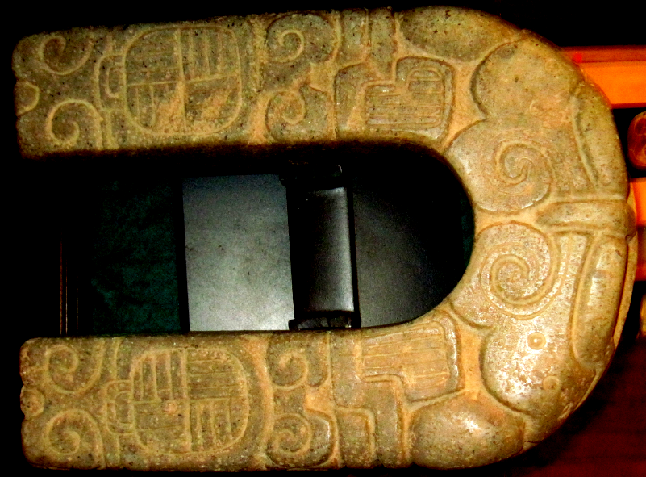­­­­

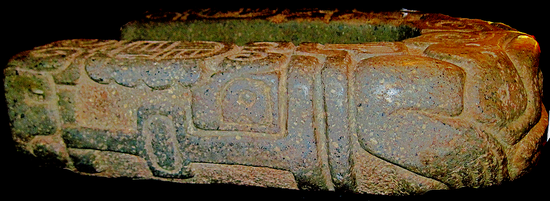

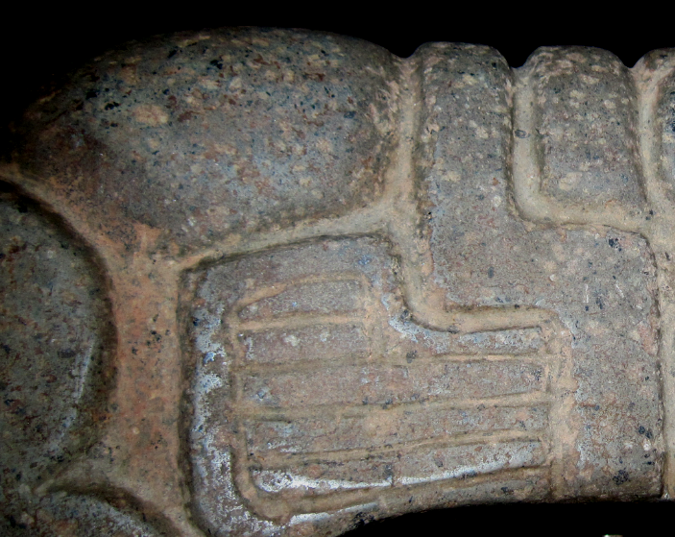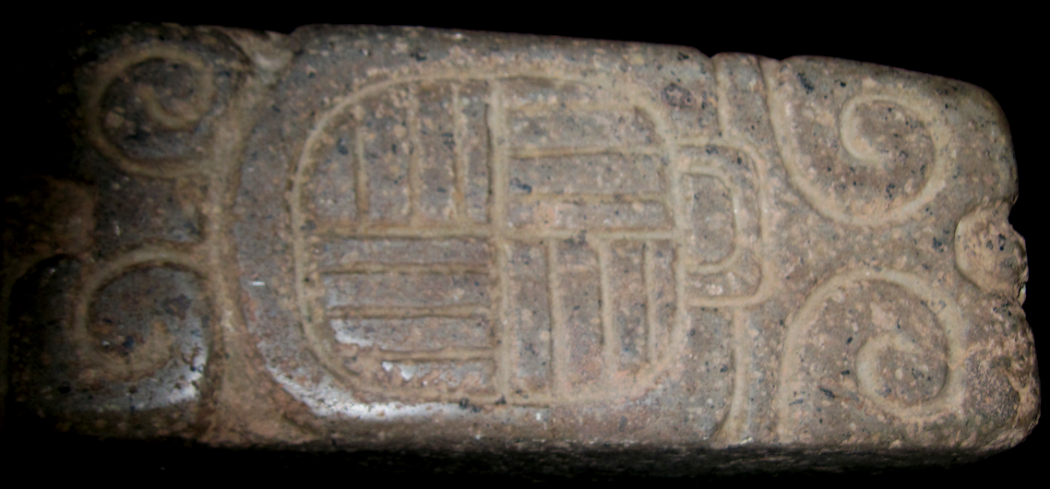

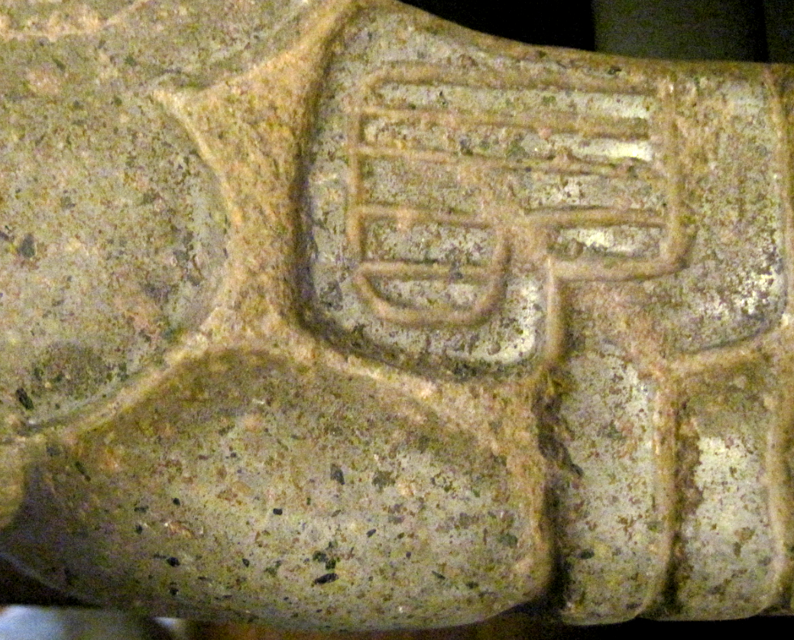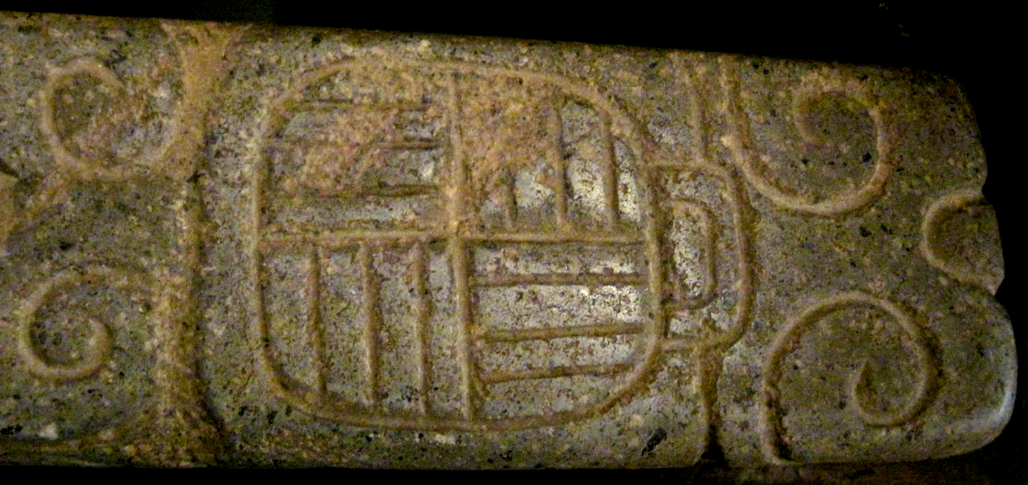





Taloc’s eyes and snout



Tlaloc’s mouth

Case no.: 10

Accession Number: 4011

Formal Label:

**Display Description:**

**Medium fine texture greenish-gray volcanic stone, well smoothed and polished on high relief areas, interior base and ends lightgly smoothed,**

**. Boldly carved toad motif. Remains of cinnabar red pigment.**

**LC Classification:**

Date or Time Horizon:

Geographical Area:

**Map:**

**GPS coordinates:**

Cultural Affiliation:

Media:

Dimensions:

Weight:

Condition:

Provenance:

**Discussion:**

**References:**

This term originates from a 1932 article by Danish archaeologist [Frans Blom](https://en.wikipedia.org/wiki/Frans_Blom), who adapted it from the [Yucatec Maya](https://en.wikipedia.org/wiki/Yucatec_Maya_language) word *pokolpok*.[[6]](https://en.wikipedia.org/wiki/Mesoamerican_ballgame" \l "cite_note-Dodson-6)[[7]](https://en.wikipedia.org/wiki/Mesoamerican_ballgame" \l "cite_note-Blom-7) In [Nahuatl](https://en.wikipedia.org/wiki/Nahuatl), the language of the Aztecs, it was called *ōllamaliztli* ([[oːlːamaˈlistɬi]](https://en.wikipedia.org/wiki/Help:IPA/Nahuatl)) or *tlachtli* ([[ˈtɬatʃtɬi]](https://en.wikipedia.org/wiki/Help:IPA/Nahuatl)). In [Classical Maya](https://en.wikipedia.org/wiki/Classical_Maya), it was known as *pitz*. It is not known precisely when or where pitz originated, although it is likely that the game originated earlier than 1400 BCE in the low-lying tropical zones home to the [rubber tree](https://en.wikipedia.org/wiki/Castilla_elastica).[[10]](https://en.wikipedia.org/wiki/Mesoamerican_ballgame" \l "cite_note-10)

One candidate for the birthplace of the ballgame is the [Soconusco](https://en.wikipedia.org/wiki/Soconusco) coastal lowlands along the Pacific Ocean.[[11]](https://en.wikipedia.org/wiki/Mesoamerican_ballgame" \l "cite_note-11) Here, at [Paso de la Amada](https://en.wikipedia.org/wiki/Paso_de_la_Amada), archaeologists have found the oldest ballcourt yet discovered, dated to approximately 1400 BCE.[[1]](https://en.wikipedia.org/wiki/Mesoamerican_ballgame" \l "cite_note-See_Hill_1998-1)

The other major candidate is the [Olmec heartland](https://en.wikipedia.org/wiki/Olmec_heartland), across the [Isthmus of Tehuantepec](https://en.wikipedia.org/wiki/Isthmus_of_Tehuantepec) along the [Gulf Coast](https://en.wikipedia.org/wiki/Gulf_Coast_of_Mexico).[[12]](https://en.wikipedia.org/wiki/Mesoamerican_ballgame" \l "cite_note-12) The [Aztecs](https://en.wikipedia.org/wiki/Aztecs) referred to their [Postclassic](https://en.wikipedia.org/wiki/Mesoamerican_chronology) contemporaries who then inhabited the region as the *Olmeca* (i.e. "rubber people") since the region was strongly identified with [latex](https://en.wikipedia.org/wiki/Latex) production.[[13]](https://en.wikipedia.org/wiki/Mesoamerican_ballgame" \l "cite_note-13) The earliest-known rubber balls come from the sacrificial bog at [El Manatí](https://en.wikipedia.org/wiki/El_Manatí), an early Olmec-associated site located in the hinterland of the [Coatzacoalcos River](https://en.wikipedia.org/wiki/Coatzacoalcos_River) drainage system. Villagers, and subsequently archaeologists, have recovered a dozen balls ranging in diameter from 10 to 22 cm from the freshwater spring there. Five of these balls have been dated to the earliest-known occupational phase for the site, approximately 1700–1600 BCE.[[14]](https://en.wikipedia.org/wiki/Mesoamerican_ballgame" \l "cite_note-14) These rubber balls were found with other ritual offerings buried at the site, indicating that even at this early date ōllamaliztli had religious and ritual connotations.[[15]](https://en.wikipedia.org/wiki/Mesoamerican_ballgame" \l "cite_note-15) A stone "yoke" of the type frequently associated with Mesoamerican ballcourts was also reported to have been found by local villagers at the site, leaving open the distinct possibility that these rubber balls were related to the ritual ballgame, and not simply an independent form of sacrificial [offering](https://en.wikipedia.org/wiki/Votive_deposit).[[16]](https://en.wikipedia.org/wiki/Mesoamerican_ballgame" \l "cite_note-16)

**Maya Ballgame**, which is a branch of the [Mesoamerican Ballgame](https://en.wikipedia.org/wiki/Mesoamerican_Ballgame), is an athletic event that was played throughout the [Maya civilization](https://en.wikipedia.org/wiki/Maya_civilization). The Maya civilization was spread out throughout much of Central America. One of the common links of the Mayan culture of Mexico, Guatemala, Honduras, and Belize is the game played with a rubber ball, about which we have learned from several sources.[[1]](https://en.wikipedia.org/wiki/Maya_Ballgame" \l "cite_note-1) Maya ballgame was played with big stone courts. The ball court itself was a focal point of Maya cities and symbolized the city’s wealth and power. The playing arena was in the shape of an I with high platforms on either side of the court allowing for large numbers of spectators. Portable stone court markers known as *hacha* usually depicting animals or skulls were placed around the [arena](https://en.wikipedia.org/wiki/Arena).[[2]](https://en.wikipedia.org/wiki/Maya_Ballgame" \l "cite_note-2) The game was played for 2 weeks.

The [Popol Vuh](https://en.wikipedia.org/wiki/Popol_Vuh) describes the history of the [K'iche' people](https://en.wikipedia.org/wiki/K'iche'_people) and their rulers and mentions the important position of the Maya ballgame. Through this ball game, a conflict of the forces of darkness and light is described and enacted. By tradition, the twin brothers, [Hun Hunaphu](https://en.wikipedia.org/w/index.php?title=Hun_Hunaphu&action=edit&redlink=1) and [Xbalanque](https://en.wikipedia.org/w/index.php?title=Vucub_Hunaphu&action=edit&redlink=1), used their time on earth to play ball. Through the noise of the game, the anger of [Vucub Came](https://en.wikipedia.org/w/index.php?title=Xibelba&action=edit&redlink=1), the master of the underworld, was aroused. A fight ensued, from which resulted in the formation of the MBG. After the game, one of the brothers was decapitated and his head was used as the game ball. From the decapitated trunk of the player, blood escaped in the form of snakes. This blood was taken as a [symbol](https://en.wikipedia.org/wiki/Symbol) of [fertility](https://en.wikipedia.org/wiki/Fertility). This scene is depicted in reliefs on the walls of MBG courts, such as the most famous example in [Chichen Itza](https://en.wikipedia.org/wiki/Chichen_Itza) in [Mexico](https://en.wikipedia.org/wiki/Mexico).[[4]](https://en.wikipedia.org/wiki/Maya_Ballgame" \l "cite_note-4) The Maya ballgame was more than just an athletic event. It was also a sacrificial and religious event. The Maya believed that it was necessary to play the game for their own survival. The ballgame provided an opportunity to show devoutness to the gods by sacrificing captured kings and high lords, or the losing opponents of the game.[[11]](https://en.wikipedia.org/wiki/Maya_Ballgame" \l "cite_note-11)

### Sacrifice and Decapitation

[Thirteen Rabbit](https://en.wikipedia.org/w/index.php?title=Thirteen_Rabbit&action=edit&redlink=1)'s ritual sacrifice shows death by decapitation and disembowelment.[[12]](https://en.wikipedia.org/wiki/Maya_Ballgame" \l "cite_note-12) Looking at sculptural portrayals this was most likely the standard technique used at [El Tajin](https://en.wikipedia.org/wiki/El_Tajin). As trophy heads were popular in Mayan Culture, it follows that they were important in ballgame.[[13]](https://en.wikipedia.org/wiki/Maya_Ballgame" \l "cite_note-13) Some death heads occurred as figurines; so sacred were the small sculptures that they were preserved and appear as offerings at non-elite burials in Late Classic domestic interments.[[14]](https://en.wikipedia.org/wiki/Maya_Ballgame" \l "cite_note-14) As stated earlier, decapitation was used as sacrifice at El Tajin. By looking at sculptures at other ballcourts decapitation was also used at [Aparicio](https://en.wikipedia.org/wiki/Aparicio), [Veracruz](https://en.wikipedia.org/wiki/Veracruz), and Chichen Itza, [Yucatan](https://en.wikipedia.org/wiki/Yucatan).[[15]](https://en.wikipedia.org/wiki/Maya_Ballgame" \l "cite_note-15) Severing of the head is also seen in the Popol Vuh. Some sources say the winning team's captain was decapitated, and at Chichen ìtza you can barely see that a squash and a couple of snakes representing Kuklkan popped out of the sacrificed captains head. This was an honor and the captain would have to accept a drink or food item.[[16]](https://en.wikipedia.org/wiki/Maya_Ballgame" \l "cite_note-16)

## Game-Play

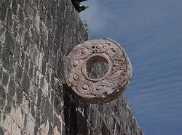

**Ballcourt goal**, [Chichén Itzá](https://en.wikipedia.org/wiki/Chichén_Itzá)

The rules seem to have changed over the centuries. Certainly two teams played against each other. The number of players varied between 2 and 6 players per team. Sometimes, an additional person is seen in the illustrations, who is believed to be a referee. The ball was put in motion by action of the right hip, the right elbow and the right knee and was not permitted to touch the ground. It could be passed from person to person in each team by propulsion by one of the above body parts. The aim was to move the ball back to the opposite team, preferably through the ring. The goal of the opposition (what today might be termed ‘the defense’) was to force the offense to lose control and to allow the ball to touch the ground. The stone ring was an innovation of the late-classic and early post-classic periods, as seen in Chichen Itza and in [Uxmal](https://en.wikipedia.org/wiki/Uxmal). Playing the ball off the border wall could intensify the game. The [ricochet](https://en.wikipedia.org/wiki/Ricochet) of the ball could hardly be anticipated, especially if the walls were uneven.[[17]](https://en.wikipedia.org/wiki/Maya_Ballgame" \l "cite_note-17)

### Equipment

A rubber ball was always used. Its size and weight varied over the centuries. Most historians assume a weight of 3–4 kg and a size of a [skittle ball](https://en.wikipedia.org/w/index.php?title=Skittle_ball&action=edit&redlink=1). The existence of a [caoutchouc tree](https://en.wikipedia.org/w/index.php?title=Caoutchouc_tree&action=edit&redlink=1) was necessary to produce the ball. These trees were found in the tropical regions in the Maya territories.[[18]](https://en.wikipedia.org/wiki/Maya_Ballgame" \l "cite_note-18)

### Dress

The usual dress for MBG players is known from iconographic and figural findings. These show leather protection mainly at the hips and the chest, but sometimes also at the knees and the arms, though very seldom at the feet. The clothing was used to protect against the impact of the ball. The protected parts of the body were used to strike the ball. Some players would wear [head dresses](https://en.wikipedia.org/w/index.php?title=Head_dresses&action=edit&redlink=1) (like deer heads) for [ritual](https://en.wikipedia.org/wiki/Ritual) reasons.[[19]](https://en.wikipedia.org/wiki/Maya_Ballgame" \l "cite_note-19)

## Physical Aspects of the Ballgame

Variations in the MBG occurred over the centuries as they have in modern ball games over years of use. Despite the variations, it would appear that the physical loads of MBG were most similar to those of soccer-tennis.[[20]](https://en.wikipedia.org/wiki/Maya_Ballgame" \l "cite_note-20) Most likely the players of ballgame manifested a [heart rate](https://en.wikipedia.org/wiki/Heart_rate) and [blood pressure](https://en.wikipedia.org/wiki/Blood_pressure) responses consistent with physical loads of light/moderate intensity, in the range of 4.5–5.5 [METs](https://en.wikipedia.org/wiki/Metabolic_equivalent). Thus, the cardiovascular demands of popular sports seem to have remained relatively similar through several millennia.[[21]](https://en.wikipedia.org/wiki/Maya_Ballgame" \l "cite_note-21)

Excavations at the nearby Olmec site of [San Lorenzo Tenochtitlán](https://en.wikipedia.org/wiki/San_Lorenzo_Tenochtitlán) have also uncovered a number of ballplayer figurines, [radiocarbon-dated](https://en.wikipedia.org/wiki/Radiocarbon_dating) as far back as 1250–1150 BCE. A rudimentary ballcourt, dated to a later occupation at San Lorenzo, 600–400 BCE, has also been identified.[[17]](https://en.wikipedia.org/wiki/Mesoamerican_ballgame" \l "cite_note-17)

From the tropical lowlands, ōllamaliztli apparently moved into central Mexico. Starting around 1000 BCE or earlier, ballplayer figurines were interred with burials at [Tlatilco](https://en.wikipedia.org/wiki/Tlatilco) and similarly styled figurines from the same period have been found at the nearby [Tlapacoya](https://en.wikipedia.org/wiki/Tlapacoya_(Mesoamerican_site)) site.[[18]](https://en.wikipedia.org/wiki/Mesoamerican_ballgame" \l "cite_note-18) It was about this period, as well, that the so-called [Xochipala](https://en.wikipedia.org/wiki/Xochipala)-style ballplayer figurines were crafted in [Guerrero](https://en.wikipedia.org/wiki/Guerrero). Although no ballcourts of similar age have been found in Tlatilco or Tlapacoya, it is possible that the ballgame was indeed played in these areas, but on courts with perishable boundaries or temporary court markers.[[19]](https://en.wikipedia.org/wiki/Mesoamerican_ballgame" \l "cite_note-19)

By 300 BCE, evidence for ōllamaliztli appears throughout much of the Mesoamerican archaeological record, including ballcourts in the Central Chiapas Valley (the next oldest ballcourts discovered, after Paso de la Amada),[[20]](https://en.wikipedia.org/wiki/Mesoamerican_ballgame" \l "cite_note-20) and in the [Oaxaca Valley](https://en.wikipedia.org/wiki/Oaxaca_Valley), as well as ceramic ballgame tableaus from Western Mexico (see photo below

## Material and formal aspects

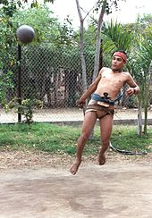

A modern [Sinaloa](https://en.wikipedia.org/wiki/Sinaloa) [ulama](https://en.wikipedia.org/wiki/Ulama_(game)) player. The outfit is similar to that worn by Aztec players.

As might be expected with a game played over such a long period of time by many cultures, details varied over time and place, so the Mesoamerican ballgame might be more accurately seen as a family of related games.

In general, the hip-ball version is most popularly thought of as *the* Mesoamerican ballgame,[[21]](https://en.wikipedia.org/wiki/Mesoamerican_ballgame" \l "cite_note-21) and researchers believe that this version was the primary—or perhaps only—version played within the [masonry](https://en.wikipedia.org/wiki/Masonry) [ballcourt](https://en.wikipedia.org/wiki/Mesoamerican_ballcourt).[[22]](https://en.wikipedia.org/wiki/Mesoamerican_ballgame" \l "cite_note-22) Ample archaeological evidence exists for games where the ball was struck by a wooden stick (e.g. a mural at Teotihuacan shows a game which resembles [field hockey](https://en.wikipedia.org/wiki/Field_hockey)), racquets, bats and batons, handstones, and the forearm, perhaps at times in combination. Each of the various types of games had its own size of ball, specialized gear and playing field, and rules.

Games were played between two teams of players. The number of players per team could vary, between 2 to 4.[[23]](https://en.wikipedia.org/wiki/Mesoamerican_ballgame" \l "cite_note-23)[[24]](https://en.wikipedia.org/wiki/Mesoamerican_ballgame" \l "cite_note-24) Some games were played on makeshift courts for simple recreation while others were formal spectacles on huge stone ballcourts leading to human sacrifice.

Even without human sacrifice, the game could be brutal and there were often serious injuries inflicted by the solid, heavy ball. Today's hip-[*ulama*](https://en.wikipedia.org/wiki/Ulama_(game)) players are "perpetually bruised"[[25]](https://en.wikipedia.org/wiki/Mesoamerican_ballgame" \l "cite_note-25) while nearly 500 years ago Spanish chronicler [Diego Durán](https://en.wikipedia.org/wiki/Diego_Durán) reported that some bruises were so severe that they had to be lanced open. He also reported that players were even killed when the ball "hit them in the mouth or the stomach or the intestines".[[26]](https://en.wikipedia.org/wiki/Mesoamerican_ballgame" \l "cite_note-26)

The rules of ōllamaliztli, regardless of the version, are not known in any detail. In modern-day [*ulama*](https://en.wikipedia.org/wiki/Ulama_(game)), the game resembles a net-less [volleyball](https://en.wikipedia.org/wiki/Volleyball),[[27]](https://en.wikipedia.org/wiki/Mesoamerican_ballgame" \l "cite_note-27) with each team confined to one half of the court. In the most widespread version of *ulama*, the ball is hit back and forth using only the hips until one team fails to return it or the ball leaves the court.

In the [Postclassic](https://en.wikipedia.org/wiki/Mesoamerican_chronology) period, the Maya began placing vertical stone rings on each side of the court, the object being to pass the ball through one, an innovation that continued into the later [Toltec](https://en.wikipedia.org/wiki/Toltec) and [Aztec](https://en.wikipedia.org/wiki/Aztec) cultures.

In the sixteenth-century Aztec ballgame that the Spaniards witnessed, points were lost by a player who let the ball bounce more than twice before returning it to the other team, who let the ball go outside the boundaries of the court, or who tried and failed to pass the ball through one of the stone rings placed on each wall along the center line.[[28]](https://en.wikipedia.org/wiki/Mesoamerican_ballgame" \l "cite_note-28) According to 16th century Aztec chronicler [Motolinia](https://en.wikipedia.org/wiki/Toribio_de_Benavente_Motolinia), points were gained if the ball hit the opposite end wall, while the decisive victory was reserved for the team that put the ball through a ring.[[29]](https://en.wikipedia.org/wiki/Mesoamerican_ballgame" \l "cite_note-29) However, placing the ball through the ring was a rare event—the rings at Chichen Itza, for example, were set 6 meters off the playing field—and most games were likely won on points.[[30]](https://en.wikipedia.org/wiki/Mesoamerican_ballgame" \l "cite_note-30)

## References

• Blumchen.

• • Palmer

• • Blumchen.

• • Blumchen.

• • Blumchen

• • Scarborough

• • Palmer

• • Scarborough

• • Scarborough

• • Scarborough

• • Palmer

• • Vilcox

• • Vilcox

• • Vilcox

• • Vilcox

• • Vilcox

• • Blumchen

• • Blumchen

• • Blumchen

• • Blumchen

• Blumchen

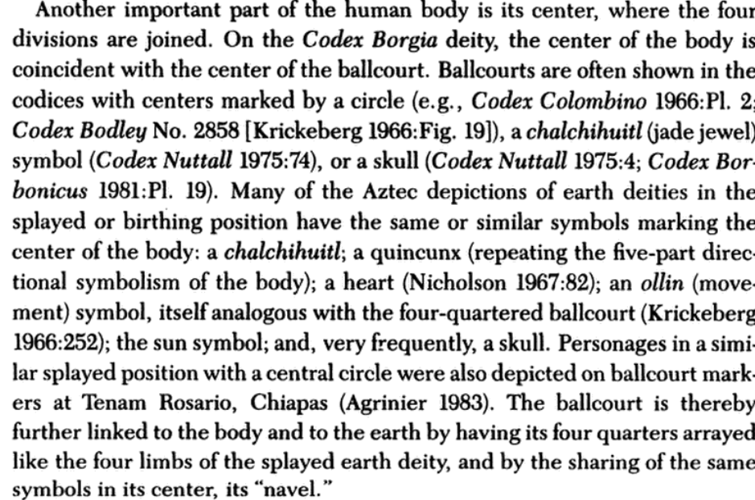

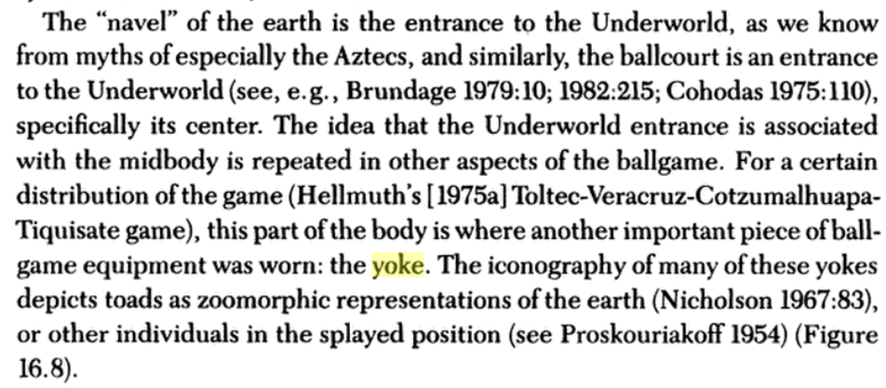

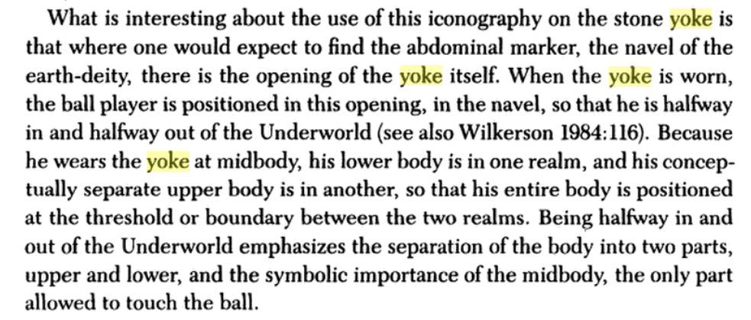

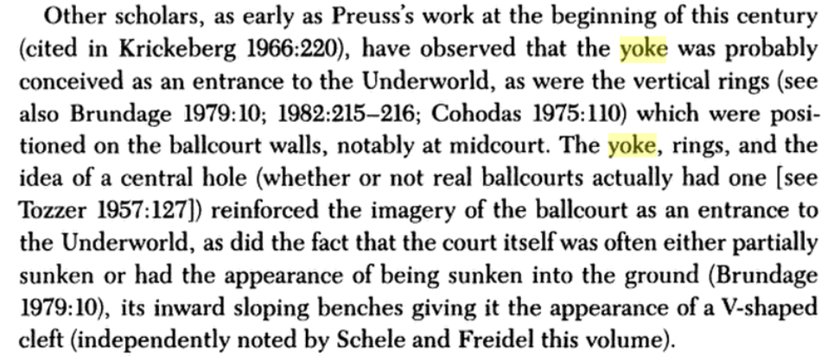

|  |  |
| --- | --- |
| Symbolism Little is known about the game's symbolic contents. Several themes recur in scholarly writing.   * Astronomy. The [bouncing ball](https://en.wikipedia.org/wiki/Bouncing_ball) is thought to have represented the sun.[[62]](https://en.wikipedia.org/wiki/Mesoamerican_ballgame" \l "cite_note-62) The stone scoring rings are speculated to signify sunrise and sunset, or equinoxes. * War. This is the most obvious symbolic aspect of the game (see also above, "Proxy for warfare"). Among the Mayas, the ball can represent the vanquished enemy, both in the late-Postclassic K'iche' kingdom (Popol Vuh), and in Classic kingdoms such as that of Yaxchilan. * Fertility. Formative period ballplayer figurines—most likely females—often wear [maize](https://en.wikipedia.org/wiki/Maize) icons.[[63]](https://en.wikipedia.org/wiki/Mesoamerican_ballgame" \l "cite_note-63) At El Tajín, the ballplayer sacrifice ensures the renewal of [pulque](https://en.wikipedia.org/wiki/Pulque), an alcoholic [maguey](https://en.wikipedia.org/wiki/Agave_americana) [cactus](https://en.wikipedia.org/wiki/Cactus) beverage. * Cosmologic duality. The game is seen as a struggle between day and night,[[64]](https://en.wikipedia.org/wiki/Mesoamerican_ballgame" \l "cite_note-64) and/or a battle between life and the underworld.[[65]](https://en.wikipedia.org/wiki/Mesoamerican_ballgame" \l "cite_note-65) Courts were considered portals to the underworld and were built in key locations within the central ceremonial precincts. Playing ball engaged one in the maintenance of the cosmic order of the universe and the ritual regeneration of life.   According to an important [Nahua](https://en.wikipedia.org/wiki/Nahuan_languages) source, the Leyenda de los Soles,[[66]](https://en.wikipedia.org/wiki/Mesoamerican_ballgame" \l "cite_note-66) the Toltec king Huemac played ball against the [Tlalocs](https://en.wikipedia.org/wiki/Tlaloc), with precious stones and quetzal feathers at stake. Huemac won the game. When instead of precious stones and feathers, the rain deities offered Huemac their young maize ears and maize leaves, Huemac refused. As a consequence of this vanity, the Toltecs suffered a four-year drought. The same ball game match, with its unfortunate aftermath, signified the beginning of the end of the Toltec reign. Maya   Ballcourt marker, from the [Maya](https://en.wikipedia.org/wiki/Maya_civilization) site of [Chinkultic](https://en.wikipedia.org/wiki/Chinkultic), dated to 591. The ball itself displays the finely incised portrait of a young deity.  The [Maya Twin myth](https://en.wikipedia.org/wiki/Maya_Hero_Twins) of the [Popol Vuh](https://en.wikipedia.org/wiki/Popol_Vuh) establishes the importance of the game (referred to in Classic Maya as *pitz*) as a symbol for warfare intimately connected to the themes of fertility and death. The story begins with the Hero Twins' father, [Hun Hunahpu](https://en.wikipedia.org/wiki/Hun_Hunahpu), and uncle, Vucub Hunahpu, playing ball near the underworld, [Xibalba](https://en.wikipedia.org/wiki/Xibalba).[[67]](https://en.wikipedia.org/wiki/Mesoamerican_ballgame" \l "cite_note-67) The lords of the underworld became annoyed with the noise from the ball playing and so the primary lords of Xibalba, One Death and Seven Death, sent owls to lure the brothers to the ballcourt of Xibalba, situated on the western edge of the underworld. Despite the danger the brothers fall asleep and are captured and sacrificed by the lords of Xibalba and then buried in the ballcourt. Hun Hunahpu is decapitated and his head hung in a fruit tree, which bears the first [calabash](https://en.wikipedia.org/wiki/Calabash) [gourds](https://en.wikipedia.org/wiki/Gourd). Hun Hunahpu's head spits into the hands of a passing goddess who conceives and bears the Hero Twins, Hunahpu and Xbalanque. The Hero Twins eventually find the ballgame equipment in their father’s house and start playing, again to the annoyance of the Lords of Xibalba, who summon the twins to play the ballgame amidst trials and dangers. In one notable episode, Hunahpu is decapitated by bats. His brother uses a squash as Hunahpu's substitute head until his real one, now used as a ball by the Lords, can be retrieved and placed back on Hunahpu's shoulders. The twins eventually go on to play the ballgame with the Lords of Xibalba, defeating them. However, the twins are unsuccessful in reviving their father, so they leave him buried in the ball court of Xibalba. The ballgame in Mesoamerican civilizationsMaya civilization   Great Ballcourt at [Chichen Itza](https://en.wikipedia.org/wiki/Chichen_Itza)  In [Maya Ballgame](https://en.wikipedia.org/wiki/Maya_Ballgame) the [Hero Twins](https://en.wikipedia.org/wiki/Maya_Hero_Twins) myth links ballcourts with death and its overcoming. The ballcourt becomes a place of transition, a liminal stage between life and death. The ballcourt markers along the centerline of the Classic playing field depicted ritual and mythical scenes of the ballgame, often bordered by a [quatrefoil](https://en.wikipedia.org/wiki/Quatrefoil) that marked a portal into another world. The Twins themselves, however, are usually absent from Classic ballgame scenes, with the [Vucub Caquix](https://en.wikipedia.org/wiki/Vucub_Caquix) of the [Copán](https://en.wikipedia.org/wiki/Copán) ball court babe, holding the severed arm of Hunahpu, as an important exception.[[68]](https://en.wikipedia.org/wiki/Mesoamerican_ballgame" \l "cite_note-68) References  * Alegría, Ricardo E. (1951). "The Ball Game Played by the Aborigines of the Antilles". [*American Antiquity*](https://en.wikipedia.org/wiki/American_Antiquity). Menasha, WI: Society for American Archaeology. **16** (4): 348–352. [*doi*](https://en.wikipedia.org/wiki/Digital_object_identifier):[*10.2307/276984*](https://doi.org/10.2307%2F276984). [*JSTOR*](https://en.wikipedia.org/wiki/JSTOR) [*276984*](https://www.jstor.org/stable/276984). [*OCLC*](https://en.wikipedia.org/wiki/OCLC) [*27201871*](https://www.worldcat.org/oclc/27201871). * Andrews, E. Wyllys (1986) [1976]. La Arqueología de Quelepa, El Salvador (in Spanish). San Salvador, El Salvador: Ministerio de Cultura y Comunicaciones. * Blanchard, Kendall (2005). The Anthropology of Sport (Revised ed.). Bergin & Garvey. [*ISBN*](https://en.wikipedia.org/wiki/International_Standard_Book_Number) [*0-89789-329-8*](https://en.wikipedia.org/wiki/Special:BookSources/0-89789-329-8). * Bradley, Douglas E.; Peter David Joralemon (1993). The Lords of Life: The Iconography of Power and Fertility in Preclassic Mesoamerica (exhibition catalogue, February 2 – April 5, 1992 ed.). Notre Dame, IN: [*Snite Museum of Art*](https://en.wikipedia.org/wiki/Snite_Museum_of_Art), University of Notre Dame. [*OCLC*](https://en.wikipedia.org/wiki/OCLC) [*29839104*](https://www.worldcat.org/oclc/29839104). * Bradley, Douglas E. (1997). Life, Death and Duality: A Handbook of the Rev. Edmund P. Joyce, C.S.C. Collection of Ritual Ballgame Sculpture. Snite Museum of Art Bulletin, Vol. 1. Notre Dame, IN: University of Notre Dame. [*OCLC*](https://en.wikipedia.org/wiki/OCLC) [*39750624*](https://www.worldcat.org/oclc/39750624). * Chinchilla Mazariegos, Oswaldo (2011). Imágenes de la mitología maya. Museo Popol Vuh, Guatemala. * [*Coe, Michael D.*](https://en.wikipedia.org/wiki/Michael_D._Coe); Dean Snow; [*Elizabeth P. Benson*](https://en.wikipedia.org/wiki/Elizabeth_P._Benson) (1986). Atlas of Ancient America. New York: Facts on File. [*ISBN*](https://en.wikipedia.org/wiki/International_Standard_Book_Number) [*0-8160-1199-0*](https://en.wikipedia.org/wiki/Special:BookSources/0-8160-1199-0). [*OCLC*](https://en.wikipedia.org/wiki/OCLC) [*11518017*](https://www.worldcat.org/oclc/11518017). * Day, Jane Stevenson (2001). "Performing on the Court". In E. Michael Whittington. The Sport of Life and Death: The Mesoamerican Ballgame (Published in conjunction with an exhibition of the same name organized by the [*Mint Museum of Art*](https://en.wikipedia.org/wiki/Mint_Museum_of_Art), Charlotte, NC. ed.). New York: Thames & Hudson. pp. 65–77. [*ISBN*](https://en.wikipedia.org/wiki/International_Standard_Book_Number) [*0-500-05108-9*](https://en.wikipedia.org/wiki/Special:BookSources/0-500-05108-9). [*OCLC*](https://en.wikipedia.org/wiki/OCLC) [*49029226*](https://www.worldcat.org/oclc/49029226). * [*Diehl, Richard*](https://en.wikipedia.org/wiki/Richard_Diehl) (2004). The Olmecs: America's First Civilization. Ancient peoples and places series. London: Thames & Hudson. [*ISBN*](https://en.wikipedia.org/wiki/International_Standard_Book_Number) [*0-500-02119-8*](https://en.wikipedia.org/wiki/Special:BookSources/0-500-02119-8). [*OCLC*](https://en.wikipedia.org/wiki/OCLC) [*56746987*](https://www.worldcat.org/oclc/56746987). * Ekholm, Susanna M. (1991). "Ceramic Figurines and the Mesoamerican Ballgame". In Vernon Scarborough; David R. Wilcox. The Mesoamerican Ballgame. Tucson: University of Arizona Press. pp. 241–249. [*ISBN*](https://en.wikipedia.org/wiki/International_Standard_Book_Number) [*0-8165-1180-2*](https://en.wikipedia.org/wiki/Special:BookSources/0-8165-1180-2). [*OCLC*](https://en.wikipedia.org/wiki/OCLC) [*22765562*](https://www.worldcat.org/oclc/22765562). * Filloy Nadal, Laura (2001). "Rubber and Rubber Balls in Mesoamerica". In E. Michael Whittington. The Sport of Life and Death: The Mesoamerican Ballgame (Published in conjunction with an exhibition of the same name organized by the [*Mint Museum of Art*](https://en.wikipedia.org/wiki/Mint_Museum_of_Art), Charlotte, NC. ed.). New York: [*Thames & Hudson*](https://en.wikipedia.org/wiki/Thames_%26_Hudson). pp. 20–31. [*ISBN*](https://en.wikipedia.org/wiki/International_Standard_Book_Number) [*0-500-05108-9*](https://en.wikipedia.org/wiki/Special:BookSources/0-500-05108-9). [*OCLC*](https://en.wikipedia.org/wiki/OCLC) [*49029226*](https://www.worldcat.org/oclc/49029226). * Garza Camino, Mercedes de la; Ana Luisa Izquierdo (1980). "El Ullamaliztli en el Siglo XVI". Estudios de Cultura Náhuatl (in Spanish). **14**: 315–333. [*ISSN*](https://en.wikipedia.org/wiki/International_Standard_Serial_Number) [*0071-1675*](https://www.worldcat.org/issn/0071-1675). * Hill, Warren D.; Michael Blake; [*John E. Clark*](https://en.wikipedia.org/wiki/John_E._Clark) (1998). "Ball court design dates back 3,400 years". Nature. **392** (6679): 878–879. [*doi*](https://en.wikipedia.org/wiki/Digital_object_identifier):[*10.1038/31837*](https://doi.org/10.1038%2F31837). * Kelly, Joyce (1996). An Archaeological Guide to Northern Central America: Belize, Guatemala, Honduras, and El Salvador. Norman: University of Oklahoma Press. [*ISBN*](https://en.wikipedia.org/wiki/International_Standard_Book_Number) [*0-8061-2858-5*](https://en.wikipedia.org/wiki/Special:BookSources/0-8061-2858-5). [*OCLC*](https://en.wikipedia.org/wiki/OCLC) [*34658843*](https://www.worldcat.org/oclc/34658843). * Kurjack, Edward B.; Ruben Maldonado C.; [*Merle Greene Robertson*](https://en.wikipedia.org/wiki/Merle_Greene_Robertson) (1991). "Ballcourts of the Northern Maya Lowlands". In Vernon Scarborough; David R. Wilcox. The Mesoamerican Ballgame. Tucson: University of Arizona Press. [*ISBN*](https://en.wikipedia.org/wiki/International_Standard_Book_Number) [*0-8165-1180-2*](https://en.wikipedia.org/wiki/Special:BookSources/0-8165-1180-2). [*OCLC*](https://en.wikipedia.org/wiki/OCLC) [*22765562*](https://www.worldcat.org/oclc/22765562). * Leyenaar, Ted (2001). "The Modern Ballgames of Sinaloa: a Survival of the Aztec Ullamaliztli". In E. Michael Whittington. The Sport of Life and Death: The Mesoamerican Ballgame (Published in conjunction with an exhibition of the same name organized by the [*Mint Museum of Art*](https://en.wikipedia.org/wiki/Mint_Museum_of_Art), Charlotte, NC ed.). New York: [*Thames & Hudson*](https://en.wikipedia.org/wiki/Thames_%26_Hudson). pp. 97–115. [*ISBN*](https://en.wikipedia.org/wiki/International_Standard_Book_Number) [*0-500-05108-9*](https://en.wikipedia.org/wiki/Special:BookSources/0-500-05108-9). [*OCLC*](https://en.wikipedia.org/wiki/OCLC) [*49029226*](https://www.worldcat.org/oclc/49029226).\*[*Motolinia, Toribio de Benavente*](https://en.wikipedia.org/wiki/Motolinia) (1903). Memoriales. Paris. * Noble, John (2006). Mexico. Lonely Planet. [*ISBN*](https://en.wikipedia.org/wiki/International_Standard_Book_Number) [*1-74059-744-3*](https://en.wikipedia.org/wiki/Special:BookSources/1-74059-744-3). * Orr, Heather (2005). "Ballgames: The Mesoamerican Ballgame". In Lindsay Jones. Encyclopedia of Religion. Detroit: Macmillan Reference, Vol. 2. pp. 749–752. * Ortíz C., Ponciano; María del Carmen Rodríguez; Alfredo Delgado (1992). "Las ofrendas de El Manatí y su posible asociación con el juego de pelota: un yugo a destiempo". In María Teresa Uriarte (ed.). El juego de pelota en Mesoamérica: raíces y supervivencia (in Spanish). México D.F.: SigloXXI Editores and Casa de Cultura, Gobierno del Estado de Sinaloa. pp. 55–67. [*ISBN*](https://en.wikipedia.org/wiki/International_Standard_Book_Number) [*968-23-1837-8*](https://en.wikipedia.org/wiki/Special:BookSources/968-23-1837-8). * Ortíz C., Ponciano; María del Carmen Rodríguez (1999). [*"Olmec Ritual Behavior at El Manatí: A Sacred Space"*](https://web.archive.org/web/20070221182955/http:/www.doaks.org/Social/social09.pdf) (PDF). In [*David C. Grove*](https://en.wikipedia.org/wiki/David_C._Grove) and [*Rosemary A. Joyce*](https://en.wikipedia.org/wiki/Rosemary_A._Joyce) (eds.). Social Patterns in Pre-Classic Mesoamerica: a symposium at Dumbarton Oaks, 9 and 10 October 1993 ([*PDF*](https://en.wikipedia.org/wiki/PDF) online reproduction) (Dumbarton Oaks etexts ed.). Washington, D.C.: [*Dumbarton Oaks Research Library and Collection*](https://en.wikipedia.org/wiki/Dumbarton_Oaks_Research_Library_and_Collection). pp. 225–254. [*ISBN*](https://en.wikipedia.org/wiki/International_Standard_Book_Number) [*0-88402-252-8*](https://en.wikipedia.org/wiki/Special:BookSources/0-88402-252-8). [*OCLC*](https://en.wikipedia.org/wiki/OCLC) [*39229716*](https://www.worldcat.org/oclc/39229716). Archived from [*the original*](http://www.doaks.org/Social/social09.pdf) (PDF) on 21 February 2007*. Retrieved 2007-06-08*. * Quirarte, Jacinto (1977). "The Ballcourt in Mesoamerica: Its Architectural Development". In Alan Cordy-Collins; Jean Stern. Pre-Columbian Art History. Palo Alto, California: Peek Publications. pp. 191–212. [*ISBN*](https://en.wikipedia.org/wiki/International_Standard_Book_Number) [*0-917962-41-9*](https://en.wikipedia.org/wiki/Special:BookSources/0-917962-41-9). * Santley, Robert M.; Berman, Michael J.; Alexander, Rami T. (1991). "The Politicization of the Mesoamerican Ballgame and Its Implications for the Interpretation of the Distribution of Ballcourts in Central Mexico". In Vernon Scarborough; David R. Wilcox. The Mesoamerican Ballgame. Tucson: University of Arizona Press. [*ISBN*](https://en.wikipedia.org/wiki/International_Standard_Book_Number) [*0-8165-1180-2*](https://en.wikipedia.org/wiki/Special:BookSources/0-8165-1180-2). [*OCLC*](https://en.wikipedia.org/wiki/OCLC) [*22765562*](https://www.worldcat.org/oclc/22765562). * Schuster, Angela M. H. (July–August 1998). [*"Newsbriefs: Mesoamerica's Oldest Ballcourt"*](http://www.archaeology.org/9807/newsbriefs/ballcourt.html). Archaeology. **41** (4). [*ISSN*](https://en.wikipedia.org/wiki/International_Standard_Serial_Number) [*0003-8113*](https://www.worldcat.org/issn/0003-8113)*. Retrieved 2007-06-08*. * [*Schele, Linda*](https://en.wikipedia.org/wiki/Linda_Schele); Miller, Mary Ellen (1986). The Blood of Kings: Dynasty and Ritual in Maya Art. Fort Worth, Texas: Kimball Art Museum. * Schwartz, Jeremy. [*"Indigenous groups keep ancient sports alive in Mexico"*](http://www.statesman.com/news/content/news/stories/world/12/19/1219mexoldsports.html). [*Austin American-Statesman*](https://en.wikipedia.org/wiki/Austin_American-Statesman)*. Retrieved 20 December 2008*.[[*dead link*](https://en.wikipedia.org/wiki/Wikipedia:Link_rot)] * Scott, John F. (2001). "Dressed to Kill: Stone Regalia of the Mesoamerican Ballgame". The Sport of Life and Death: The Mesoamerican Ballgame (Published in conjunction with an exhibition of the same name organized by the [*Mint Museum of Art*](https://en.wikipedia.org/wiki/Mint_Museum_of_Art), Charlotte, NC. ed.). New York: Thames & Hudson. pp. 51–63. [*ISBN*](https://en.wikipedia.org/wiki/International_Standard_Book_Number) [*0-500-05108-9*](https://en.wikipedia.org/wiki/Special:BookSources/0-500-05108-9). * Shelton, Anthony A. (2003). "The Aztec Theatre State and the Dramatization of War". In Tim Cornell; Thomas B. Allen. War and Games. New York: Boydell Press. [*ISBN*](https://en.wikipedia.org/wiki/International_Standard_Book_Number) [*978-0-85115-870-9*](https://en.wikipedia.org/wiki/Special:BookSources/978-0-85115-870-9). * Smith, Michael E. (2003). The Aztecs. Oxford: Blackwell Publishers. * Taladoire, Eric; Benoit Colsenet (1991). "'Bois Ton Sang, Beaumanior':The Political and Conflictual Aspects of the Ballgame in the Northern Chiapas Area". In Vernon Scarborough; David R. Wilcox. The Mesoamerican Ballgame. Tucson: University of Arizona Press. [*ISBN*](https://en.wikipedia.org/wiki/International_Standard_Book_Number) [*0-8165-1180-2*](https://en.wikipedia.org/wiki/Special:BookSources/0-8165-1180-2). [*OCLC*](https://en.wikipedia.org/wiki/OCLC) [*22765562*](https://www.worldcat.org/oclc/22765562). * Taladoire, Eric (2001). "The Architectural Background of the Pre-Hispanic Ballgame". The Sport of Life and Death: The Mesoamerican Ballgame (Published in conjunction with an exhibition of the same name organized by the [*Mint Museum of Art*](https://en.wikipedia.org/wiki/Mint_Museum_of_Art), Charlotte, NC ed.). New York: Thames & Hudson. pp. 97–115. [*ISBN*](https://en.wikipedia.org/wiki/International_Standard_Book_Number) [*0-500-05108-9*](https://en.wikipedia.org/wiki/Special:BookSources/0-500-05108-9). [*OCLC*](https://en.wikipedia.org/wiki/OCLC) [*49029226*](https://www.worldcat.org/oclc/49029226). * Taladoire, Eric (4 March 2004). [*"Could We Speak of the Super Bowl at Flushing Meadows?: La Pelota Mixteca, a Third Pre-Hispanic Ballgame, and its Possible Architectural Context"*](http://journals.cambridge.org/action/displayAbstract;jsessionid=DC6E94E592F567966284E1376A6828D8.tomcat1?fromPage=online&aid=186662). Ancient Mesoamerica. **14** (02): 319–342. [*doi*](https://en.wikipedia.org/wiki/Digital_object_identifier):[*10.1017/S0956536103132142*](https://doi.org/10.1017%2FS0956536103132142). * Velázquez, Primo Feliciano (translator) (1975). Códice Chimalpopoca: Anales de Cuauhtitlan y Leyenda de los Soles. Mexico: UNAM. * Wilkerson, S. Jeffrey K. (1991). "Then They Were Sacrificed: The Ritual Ballgame of Northeastern Mesoamerica Through Time and Space". In Vernon Scarborough; David R. Wilcox. The Mesoamerican Ballgame. Tucson: University of Arizona Press. [*ISBN*](https://en.wikipedia.org/wiki/International_Standard_Book_Number) [*0-8165-1180-2*](https://en.wikipedia.org/wiki/Special:BookSources/0-8165-1180-2). [*OCLC*](https://en.wikipedia.org/wiki/OCLC) [*22765562*](https://www.worldcat.org/oclc/22765562).  Further reading Berdan, Frances F. (2005). The Aztecs of Central Mexico: An Imperial Society. Case Studies in Cultural Anthropology (2nd ed.). Belmont, CA: Thomson Wadsworth. [*ISBN*](https://en.wikipedia.org/wiki/International_Standard_Book_Number) [*0-534-62728-5*](https://en.wikipedia.org/wiki/Special:BookSources/0-534-62728-5). [*OCLC*](https://en.wikipedia.org/wiki/OCLC) [*55880584*](https://www.worldcat.org/oclc/55880584).  [California State University, Los Angeles](https://en.wikipedia.org/wiki/California_State_University,_Los_Angeles), Department of Anthropology, ["Proyecto Ulama 2003"](http://www.calstatela.edu/academic/anthro/jbrady/ulama/proyectoulama.htm), accessed October 2007.  Carrasco, David; Scott Sessions (1998). Daily Life of the Aztecs: People of the Sun and Earth. The Greenwood Press "Daily Life Through History" series [*ISSN*](https://en.wikipedia.org/wiki/International_Standard_Serial_Number) [*1080-4749*](https://www.worldcat.org/search?fq=x0:jrnl&q=n2:1080-4749). Westport CT: Greenwood Press. [*ISBN*](https://en.wikipedia.org/wiki/International_Standard_Book_Number) [*0-313-29558-1*](https://en.wikipedia.org/wiki/Special:BookSources/0-313-29558-1). [*OCLC*](https://en.wikipedia.org/wiki/OCLC) [*37552549*](https://www.worldcat.org/oclc/37552549).  Christenson, Allen J. (2007). Popol Vuh: The Sacred Book of the Maya: The Great Classic of Central American Spirituality. University of Oklahoma Press. [*ISBN*](https://en.wikipedia.org/wiki/International_Standard_Book_Number) [*978-0-8061-3839-8*](https://en.wikipedia.org/wiki/Special:BookSources/978-0-8061-3839-8).  [*Colas, Pierre*](https://en.wikipedia.org/wiki/Pierre_Colas); Alexander Voss (2006). "A Game of Life and Death – The Maya Ball Game". In [*Nikolai Grube*](https://en.wikipedia.org/wiki/Nikolai_Grube) (ed.). Maya: Divine Kings of the Rain Forest. Eva Eggebrecht and Matthias Seidel (assistant eds.). Cologne, Germany: Könemann. pp. 186–191. [*ISBN*](https://en.wikipedia.org/wiki/International_Standard_Book_Number) [*3-8331-1957-8*](https://en.wikipedia.org/wiki/Special:BookSources/3-8331-1957-8). [*OCLC*](https://en.wikipedia.org/wiki/OCLC) [*71165439*](https://www.worldcat.org/oclc/71165439).  Espinoza, Mauricio (2002). [*"El Corazón del Juego: El Juego de Pelota Mesoamericano como Texto Cultural en la Narrativa y el Cine Contemporáneo"*](https://web.archive.org/web/20070524065929/http:/www.denison.edu/collaborations/istmo/n04/proyectos/corazon.html). Istmo (in Spanish). **4**. [*ISSN*](https://en.wikipedia.org/wiki/International_Standard_Serial_Number) [*1535-2315*](https://www.worldcat.org/issn/1535-2315). Archived from [*the original*](http://www.denison.edu/collaborations/istmo/n04/proyectos/corazon.html) on 2007-05-24.  Foster, Lynn V. (2002). Handbook to Life in the Ancient Maya World. Facts on File Library of World History. New York: Facts On File. [*ISBN*](https://en.wikipedia.org/wiki/International_Standard_Book_Number) [*0-8160-4148-2*](https://en.wikipedia.org/wiki/Special:BookSources/0-8160-4148-2).  Hosler, Dorothy; Sandra Burkett; Michael Tarkanian (1999-06-18). "Prehistoric Polymers: Rubber Processing in Ancient Mesoamerica". [*Science*](https://en.wikipedia.org/wiki/Science_(journal)). **284** (5422): 1988–1991. [*doi*](https://en.wikipedia.org/wiki/Digital_object_identifier):[*10.1126/science.284.5422.1988*](https://doi.org/10.1126%2Fscience.284.5422.1988). [*PMID*](https://en.wikipedia.org/wiki/PubMed_Identifier) [*10373117*](https://www.ncbi.nlm.nih.gov/pubmed/10373117).  McKillop, Heather I. (2004). The Ancient Maya: New Perspectives. Santa Barbara, CA: ABC-CLIO. [*ISBN*](https://en.wikipedia.org/wiki/International_Standard_Book_Number) [*1-57607-697-0*](https://en.wikipedia.org/wiki/Special:BookSources/1-57607-697-0). [*OCLC*](https://en.wikipedia.org/wiki/OCLC) [*56558696*](https://www.worldcat.org/oclc/56558696).  Metropolitan Museum of Art (2002). "Recent Acquisitions, A selection 2001–2002". The Metropolitan Museum of Art Bulletin. **LX** (2). [*ISSN*](https://en.wikipedia.org/wiki/International_Standard_Serial_Number) [*0026-1521*](https://www.worldcat.org/issn/0026-1521).  [*Miller, Mary Ellen*](https://en.wikipedia.org/wiki/Mary_Miller_(art_historian)) (2001). "The Maya Ballgame: Rebirth in the Court of Life and Death". The Sport of Life and Death: The Mesoamerican Ballgame (Published in conjunction with an exhibition of the same name organized by the [*Mint Museum of Art*](https://en.wikipedia.org/wiki/Mint_Museum_of_Art), Charlotte, NC. ed.). New York: [*Thames & Hudson*](https://en.wikipedia.org/wiki/Thames_%26_Hudson). pp. 20–31. [*ISBN*](https://en.wikipedia.org/wiki/International_Standard_Book_Number) [*0-500-05108-9*](https://en.wikipedia.org/wiki/Special:BookSources/0-500-05108-9). [*OCLC*](https://en.wikipedia.org/wiki/OCLC) [*49029226*](https://www.worldcat.org/oclc/49029226).  [*Miller, Mary Ellen*](https://en.wikipedia.org/wiki/Mary_Miller_(art_historian)); [*Simon Martin*](https://en.wikipedia.org/wiki/Simon_Martin_(Mayanist)) (2004). Courtly Art of the Ancient Maya. London: [*Thames & Hudson*](https://en.wikipedia.org/wiki/Thames_%26_Hudson). [*ISBN*](https://en.wikipedia.org/wiki/International_Standard_Book_Number) [*0-500-05129-1*](https://en.wikipedia.org/wiki/Special:BookSources/0-500-05129-1). [*OCLC*](https://en.wikipedia.org/wiki/OCLC) [*54799516*](https://www.worldcat.org/oclc/54799516).  Wilcox, David R. (1991). "The Mesoamerican Ballgame in the American Southwest". In Vernon Scarborough; David R. Wilcox. The Mesoamerican Ballgame. Tucson: [*University of Arizona Press*](https://en.wikipedia.org/wiki/University_of_Arizona_Press). pp. 101–125. [*ISBN*](https://en.wikipedia.org/wiki/International_Standard_Book_Number) [*0-8165-1180-2*](https://en.wikipedia.org/wiki/Special:BookSources/0-8165-1180-2). [*OCLC*](https://en.wikipedia.org/wiki/OCLC) [*22765562*](https://www.worldcat.org/oclc/22765562).  Zender, Mark (2004). [*"Glyphs for "Handspan" and "Strike" in Classic Maya Ballgame Texts"*](https://web.archive.org/web/20080910095804/http:/www.mesoweb.com/pari/publications/journal/404/Handspan.pdf) (PDF). The PARI Journal. **IV** (4). [*ISSN*](https://en.wikipedia.org/wiki/International_Standard_Serial_Number) [*0003-8113*](https://www.worldcat.org/issn/0003-8113). Archived from [*the original*](http://www.mesoweb.com/pari/publications/journal/404/Handspan.pdf) (PDF) on 2008-09-10. ORDER DATEApr 13, 2016 | ORDER TOTAL  US $5,000.00  + US $100.00  shipping  **Order Pre-columbian Mayan Ball Game Yoke** [Leave feedback - ORDER DATE Apr 13, 2016](http://feedback.ebay.com/ws/eBayISAPI.dll?LeaveFeedbackShow&useridto=prehispanic56&transactID=1833837897015&item=252352947177&_trksid=p2057872.m2749.l2665)[View order details](http://payments.ebay.com/ws/eBayISAPI.dll?ViewPaymentStatus&transId=1833837897015&itemid=252352947177&_trksid=p2057872.m2749.l2673) - ORDER DATE Apr 13, 2016  [More actions - ORDER DATE Apr 13, 2016](http://www.ebay.com/myb/PurchaseHistory) |

1 item sold by [prehispanic56](http://www.ebay.com/usr/prehispanic56?_trksid=p2057872.m2749.l2754)

|  |  |  |
| --- | --- | --- |
| [Pre-columbian Mayan Ball Game Yoke](http://www.ebay.com/itm/252352947177?_trksid=p2057872.m2749.l2649&ssPageName=STRK%3AMEBIDX%3AIT)  ( 252352947177 )  Delivered on Mon, Apr 18  Tracking number: [**Tracking number**9505513444886107141734](javascript:;)  [Add note](javascript:;) | ITEM PRICE:  US $5,000.00 |  |